## 实验8 File Processing

## 学号: 09017423 姓名：杨彬

### 实验目的

1. To create, read, and write sequential-access files

Experiments

### 实验内容

**Exp1:** **Description of the Problem**

Suppose we wish to process survey results that are stored in a file. This exercise requires two separate programs. First, create a program that prompts the user for survey responses and outputs each response to a file. Use an ofstream to create a file called "numbers.txt". Then create a program to read the survey responses from "numbers.txt". The responses should be read from the file by using an ifstream. Input one integer at a time from the file. The program should continue to read responses until it reaches the end of file. The results should be output to the text file "output.txt".

**Exp2:** **Description of the Problem**

(1) Create a simple sequential-access file-processing program that might be used by professors to help manage their student records. For each student, the program should obtain an ID number, the student’s first name, the student’s last name and the student’s grade. The data obtained for each student constitutes a record for the student and should be stored in an object of a class called Student. The program should save the records in a sequential file specified by the user (for example “file.dat”).

Contents of file.dat

253 Bill Purple 88.9

632 Debbie Green 91.2

412 Steven Red 94.7

522 Mike Blue 83.8

(2) Create a simple sequential-access file-processing program to complement the program in (1). This program should open the file created by (1) and read and display the grade information for each student. The program should also display the class average

### 实验代码及结果：

**Exp1:** 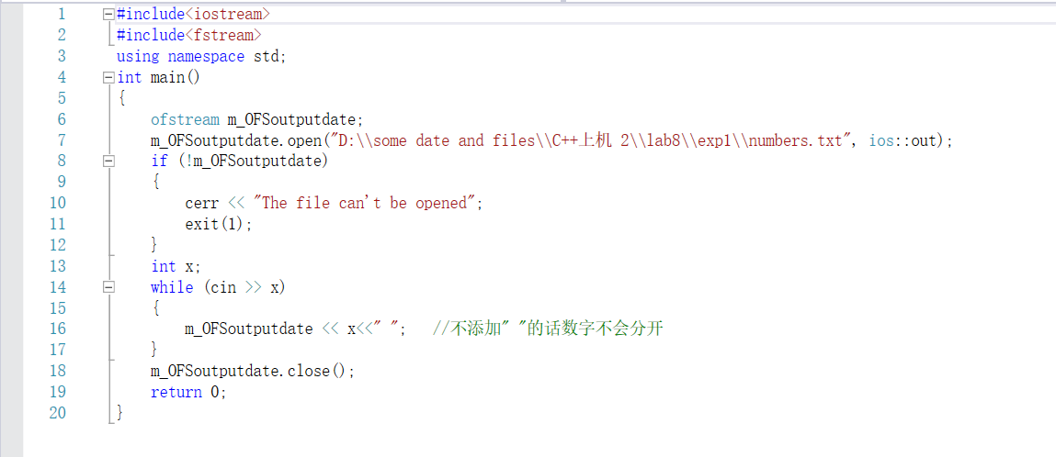

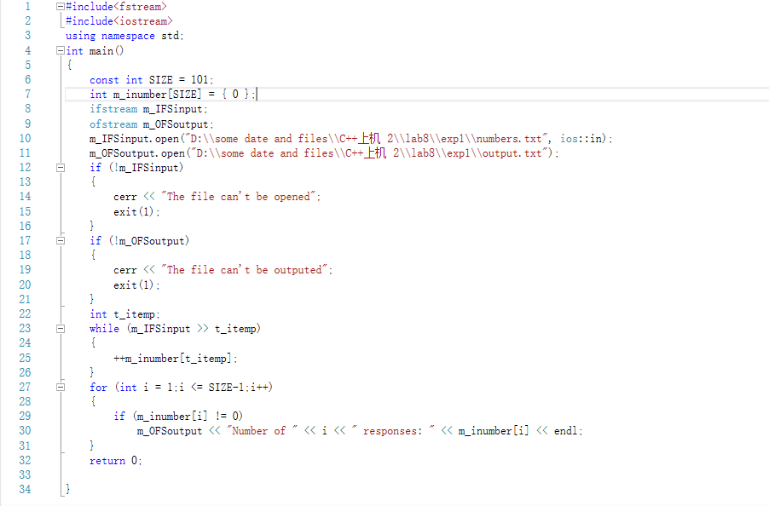

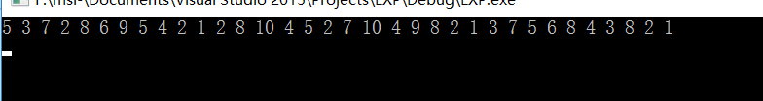

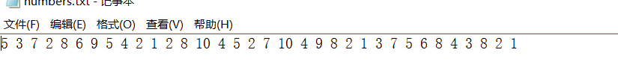

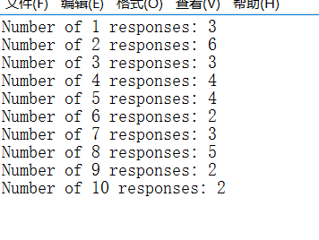

**Exp2:**

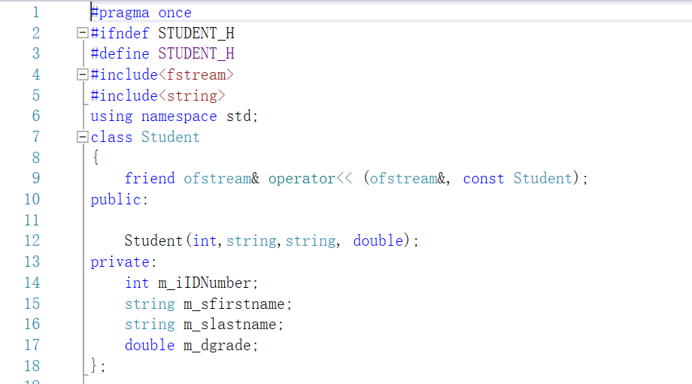

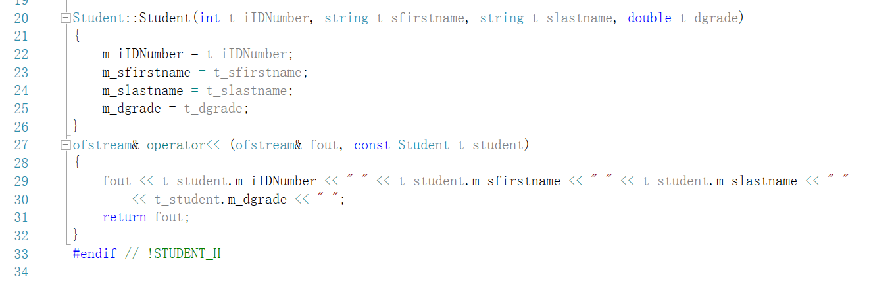

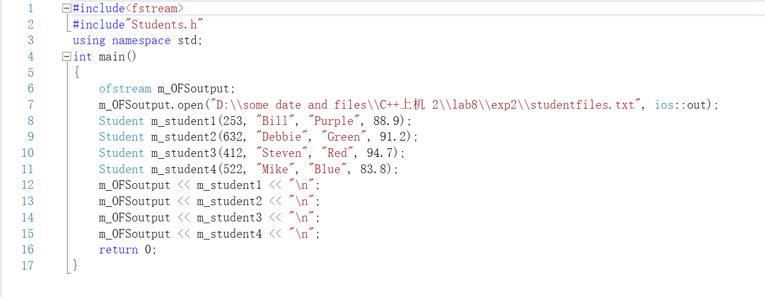

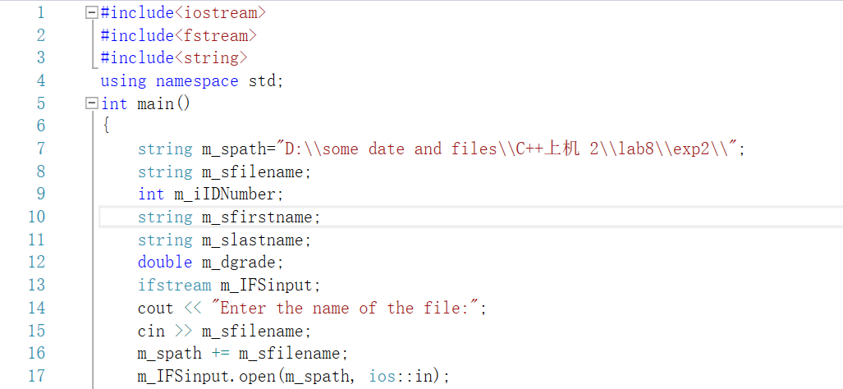

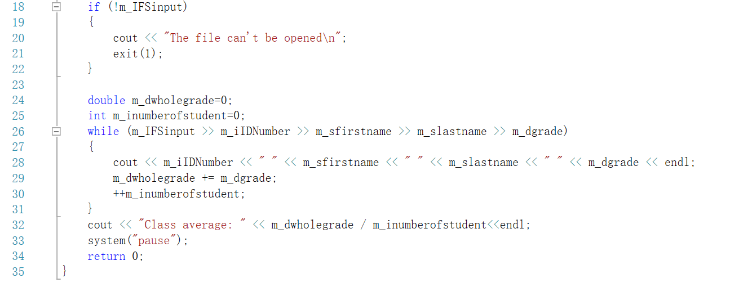

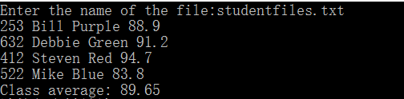

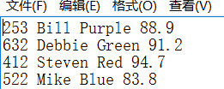

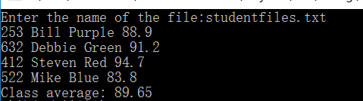

### 遇到的问题及解决过程

**Exp1:nothing**

**Exp2:nothing**

### 实验体会

**Exp1、Exp2:**

:通过这个实验学会了基本的文件流的操作（包括输出流和输入流）先打开流，然后和使用标准输入输出流一样来使用（在打开方式不是使用二进制打开的时候）但是文件流操作有两个要注意的地方1应该先判断文件是否成功打开2在操作结束后应该手动关闭文件流。

此外还要注意一点，在文件流的操作中打开文件的时候一定要记得\符号要改成\\（因为转义字符）